Measuring the pulse of prosperity: An index of economic freedom analysis

**Mentor name – SRI L LAKSHMI NARAYANA**

**TEAM ID – LTVIP2025TMID52563**

**TEAM LEADER**

****NAME- G NAVEEN**  
**MAIL –** [**naveen232214@gmail.com**](mailto:naveen232214@gmail.com)

**ID NO – SBAP0052563**

**ROLL NO- 233888102016**

**TEAM MEMBERS**

****NAME- KLSV SURYA VAMSI**

**MAIL-** [**lohithk2211@gmail.com**](mailto:lohithk2211@gmail.com)

**ID NO – SBAP0052620**

**ROLL NO - 233888102020**



**NAME- R NITEESH**

**MAIL-** [**rongalaniteesh000@gmail.com**](mailto:rongalaniteesh000@gmail.com)

**ID NO- SBAP0052592**

**ROLL NO- 233888102040**



**NAME- B MAHESH DURGA RAJU**

**MAIL-** [**maheshdurgaraju@gmail.com**](mailto:maheshdurgaraju@gmail.com)

**ID NO-SBAP0052626**

**ROLL NO- 233888102007**



**NAME- B SRI RAM SAI NARASIMHAMURTHY**

[**MAIL-badamnarasimha405@gmail.com**](mailto:MAIL-badamnarasimha405@gmail.com)

**ID NO – SBAP0052639**

**ROLL NO - 233888102005**

**TEAM GROUP PHOTO  


**Measuring the Pulse of Prosperity: An Index of Economic Freedom Analysis**

Introduction :

Economic freedom is the fundamental right of every human to control his or her own labor and property. In an economically free society, individuals are free to work, produce, consume, and invest in any way they please. In economically free societies, governments allow labor, capital, and goods to move freely, and refrain from coercion or constraint of liberty beyond the extent necessary to protect and maintain liberty itself.

For much of human history, most individuals have lacked economic freedom and opportunity, condemning them to poverty and deprivation.

Today, we live in the most prosperous time in human history. Poverty, sicknesses, and ignorance are receding throughout the world, due in large part to the advance of economic freedom. In 2022, the principles of economic freedom that have fueled this monumental progress are once again measured in the Index of Economic Freedom, an annual guide published by The Heritage Foundation, Washington's No. 1 think tank.

We measure economic freedom based on 12 quantitative and qualitative factors, grouped into four broad categories, or pillars, of economic freedom:

1. Rule of law property rights, government integrity, judicial effectiveness)
2. Government size (government spending, tax burden, fiscal health)
3. Regulatory efficiency (business freedom, labor freedom, monetary freedom)
4. Open markets (trade freedom, investment freedom, financial freedom)

Technical Architecture :

<https://lh5.googleusercontent.com/zo9KZ-C8r-Q1FZW_-x2b54ktUMT8jLbjvGwTZ9O82L-BaorDR4rYv8TeIKgRs9tZDr7oGXGp844YFpWTHJL-GrEFz8NzmZoGzsVM-60ViuDthJjkg3vwe3P_jAlAQg4nt6WettKcZDC7epMrllrGZnWfKY7i0Mr7SKiQzV-Zaa33CG2tl2ZSg0uAqd8hFR40DtO-vX9z>

**Pre requisites**

For Completing this project these are some of the prerequisites needed

* A system with a minimum 4GB RAM and 128GB Hard Disk
* Good Internet Connection
* Google Drive / Any of the Database Server with Management Studio
* MySQL:

<https://youtu.be/2c2fUOgZMmY>

**SQL Server Management Studio:**

<https://youtu.be/kGdTg-vGs-E>

**Tableau Desktop:**

<https://youtu.be/b3pWYyrHQo8>

* Tableau Public Account: <https://public.tableau.com/app/discover>
* Html, CSS or Bootstrap

**Prior Knowledge**

To Complete this project, one must understand the below concepts and able to work with the tools

* **Data Visualization:**

<https://youtu.be/5gpnZvMSTZs>

**Uni-Variate, Bi- Variate and Multi-Variate Analysis:**

<https://youtu.be/JG8GRlMjp3c>

* **Chart Types:**

<https://youtu.be/csXmVBw8cdo>

* **Tableau:**

<https://youtu.be/aHaOIvR00So>

* **Business Intelligence:**
* <https://youtu.be/Hg8zBJ1DhLQ>

**Project Objectives**

By the end of this project, you will:

* Able to Connect Tableau with different data sources
* Know fundamental concepts and techniques used for Data Visualization.
* Gain a broad understanding about data and different types of charts.
* Have knowledge on developing Visualizations, Dashboards and Story.
* Able to Integrate the developed dashboard and story with the web application

**Project Flow**

To accomplish this, we have to complete all the activities listed below,

* Data collection
  + Collect the dataset or create the dataset
* Database /Spreadsheet Connection
  + Understand the dataset
  + Import Dataset into the database
  + Connect Tableau Desktop to Database server.
* Visualizing and analysing data
* Understand the Data and the Business Questions
* Based on the Business questions develop the different visualizations
* Dashboard
  + Develop the Dashboard
* Story
  + Develop the Storyboard
* Publishing to the Tableau Public & Web Application Integration
  + Developed Visualizations, Dashboard and story will be published to Tableau Public Account.
  + Once it is published, we will get the shareable links
  + Develop a web application using HTML, CSS or Using Bootstrap
  + Integrate the Visualizations, Dashboard and Story with the Web Application

**Data Collection**

Data collection is the process of gathering and measuring information on variables of interest, in an established systematic fashion that enables one to answer stated research questions, test hypotheses, and evaluate outcomes and generate insights from the data.

**Downloading the dataset**

You can download the dataset from this link : [Link](https://drive.google.com/file/d/1EBIa1LtM3Ni2Uh3nekLB6wt3263Q3NeX/view?usp=share_link)

**Working with Dataset**

**Understand the data:**

**This dataset was taken from heritage.org ‘2022 Index of economic freedom’**

**to know more about the data . check out this link**

[**link**](https://www.heritage.org/index/explore)

**Import Dataset into Database and connect Tableau Desktop to Database server**

**Explanation video link :** [**link**](https://drive.google.com/file/d/1KcobxcoW76hPceVUOvvFp5rGoJNe6TBU/view?usp=share_link)

**Data Visualization**

**Data visualization is the process of creating graphical representations of data in order to help people understand and explore the information. The goal of data visualization is to make complex data sets more accessible, intuitive, and easier to interpret. By using visual elements such as charts, graphs, and maps, data visualizations can help people quickly identify patterns, trends, and outliers in the data.**

**2022 Economic freedom score**

**This map/visualization demonstrates the index score of all the 176 countries in the dataset**

**Explanation video link :**

[**link**](https://drive.google.com/file/d/13CE32SYAoTsFFAKFzmq-Mhwc3N9Usw7G/view?usp=share_link)

**2022 Economic freedom score**

**This map/visualization demonstrates the index score of all the 176 countries in the dataset**

**Explanation video link :**

[**link**](https://drive.google.com/file/d/13CE32SYAoTsFFAKFzmq-Mhwc3N9Usw7G/view?usp=share_link)

**Top 40 ranking countries in the index**

**This Map demonstrates the top 40 ranking countries according to the 2022 economic freedom index**

**Explanation video link :**

[**link**](https://drive.google.com/file/d/1rOxLgoLTtWRboslA0eclL3MlaxVS88SS/view?usp=share_link)

**Bottom ranking countries in the index**

**This map demonstrates the bottom ranking countries according to the 2022 economic index freedom**

**Explanation video link :**

[**link**](https://drive.google.com/file/d/1W2QFKBj3dBXBoNMFjd4o9nGrEthIqNiX/view?usp=share_link)

**Index score based on unemployment rate**

This column chart demonstrates the unemployment across different countries and its effect on the final index score

[link](https://drive.google.com/file/d/1A4Y3u4Y3jfX5cub1KXTPNDE4S84__XoT/view?usp=share_link)

**Index score based on financial freedom**

This treemap demonstrates the effect of financial freedom on the index score. we can see from the map that, countries in sub-saharan africa have lesser extent of financial freedom

**Explanation video link :**

[**link**](https://drive.google.com/file/d/1GKFDc9on4jdem3GojLxqjsBH1Nt1Iz78/view?usp=share_link)

**Index score based on population**

This horizontal bar chart demonstrates if population of a country is in anyway affecting the final index score of a country

**Explanation video link :** [**link**](https://drive.google.com/file/d/1MLIRwpo6E82y3iT6zOHD3BtyvnmVOKJB/view?usp=share_link)

**Index score based on 5 year on GDP growth rate(%)**

This gantt bar chart demonstrates the effect of 5 year GDP growth rate % on final index score

**Explanation video link :**

[**link**](https://drive.google.com/file/d/12A3Zd5IzO3IEALnXBoRG-nNRjLp43iL7/view?usp=share_link)

**Inflation rate in different countries**

This area chart describes the effect of inflation on final standing of a country.as we can see, venezuela has the worst inflation in the world.

**Explanation video link :**

[link](https://drive.google.com/file/d/1bqW0bWVjuMEyDBrmmgQsGrpGv1Tnj57q/view?usp=share_link)

**Correlation between inflation and unemployment**

This line graph demonstrates the correlation between inflation and unemployment. we observe from the graph that, inflation and unemployment are closely related

Explanation video link : [link](https://drive.google.com/file/d/1A4Y3u4Y3jfX5cub1KXTPNDE4S84__XoT/view?usp=share_link)

**Correlation between GDP(PPP) and monetary freedom**

This line graph demonstrates the correlation between GDP per capita (PPP) and monetary freedom of a country

Explanation video link : [link](https://drive.google.com/file/d/1_GzxL_TI6qCQezepNGFqcveB14WNrCND/view?usp=share_link)

**Top 40 countries by GDP growth rate**

This chart demonstrates the GDP growth rate of different countries, and the effect of it on their final rank

Explanation video link : [link](https://drive.google.com/file/d/1xIYt6iys2V4YNxyE9o-QknQiX4CW7zPc/view?usp=share_link)

**Dashboard**

Dashboard can be defined as an information management tool that visually tracks, analyses, and displays key performance indicators (KPI), metrics, as well as key data points, allowing you to monitor the current state of your business, department, team, or specific process.

**Creating the Dashboard**

Once you have created views on different sheets in Tableau, you can pull them into a dashboard.

Explanation video link: [link](https://drive.google.com/file/d/166EwgSCGp0aWeay-81X95AcuqQJ2edIc/view?usp=share_link)

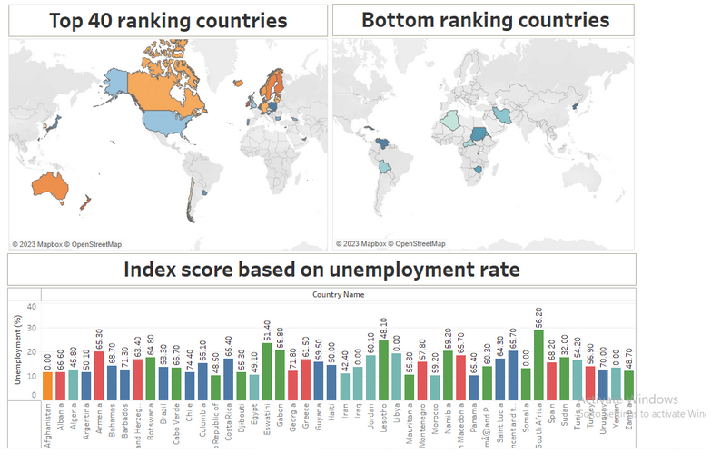

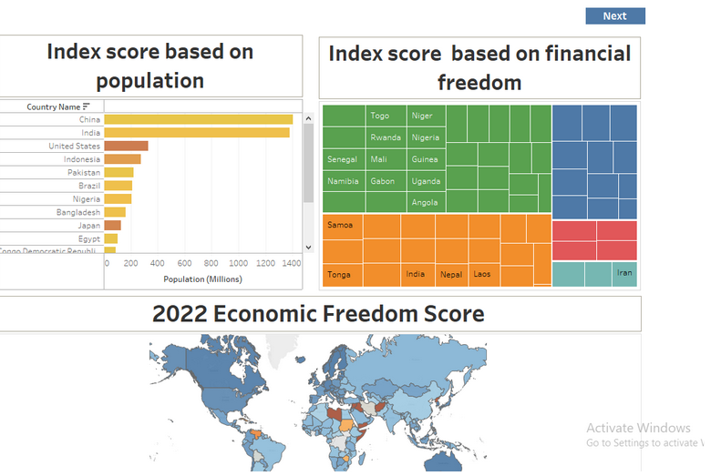

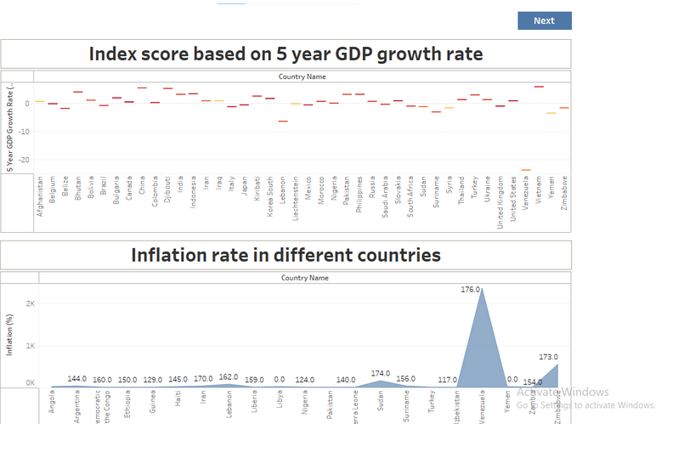

**Story**

A data story is a way of presenting data and analysis in a narrative format, with the goal of making the information more engaging and easier to understand. A data story typically includes a clear introduction that sets the stage and explains the context for the data, a body that presents the data and analysis in a logical and systematic way, and a conclusion that summarizes the key findings and highlights their

**Creating the story board**

Explanation video link: [link](https://drive.google.com/file/d/1nLRTIraarip2s0OfXzNHYaqz_PcGqsO2/view?usp=share_link)

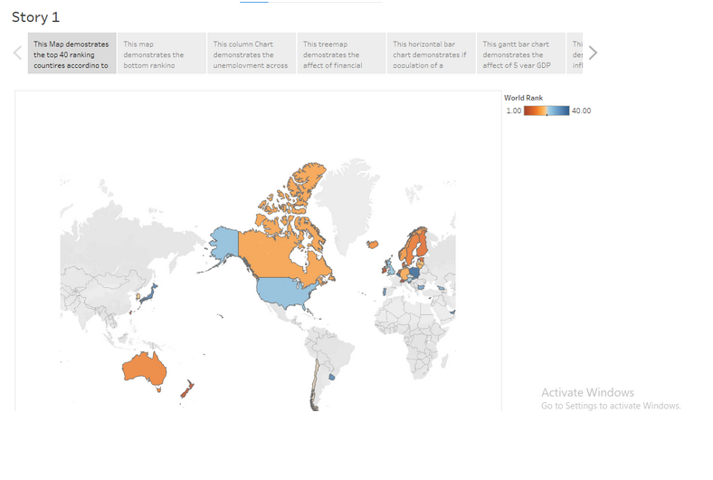

**Publishing and Web integration**

Publishing helps us to track and monitor key performance metrics, to communicate results and progress. help a publisher stay informed, make better decisions, and communicate their performance to others.

Explanation video link: [link](https://drive.google.com/file/d/1F-fkjU9niidfU6OL0ANaT58Rhf0c7k7c/view?usp=share_link)

**Publishing dashboard and reports to tableau public**

Step 1: Go to Dashboard/story, click on share button on the top ribbon

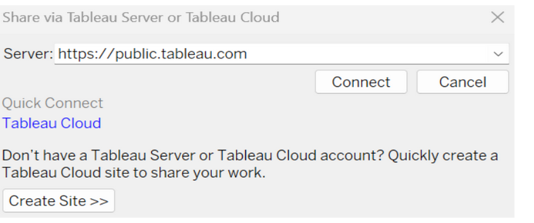

Give the server address of your tableau public account and click on connect.

Step 2: Once you click on connect it will ask you for tableau public user name and password

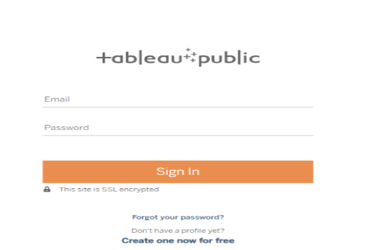

Once you login into your tableau public using the credentials, the particular visualization will be published into tableau public

Note: While publishing the visualization to the public, the respective sheet will get published when you click on share option.

**Integrating with Web with Embed code**

Explanation video link: [link](https://drive.google.com/file/d/1F-fkjU9niidfU6OL0ANaT58Rhf0c7k7c/view?usp=share_link)

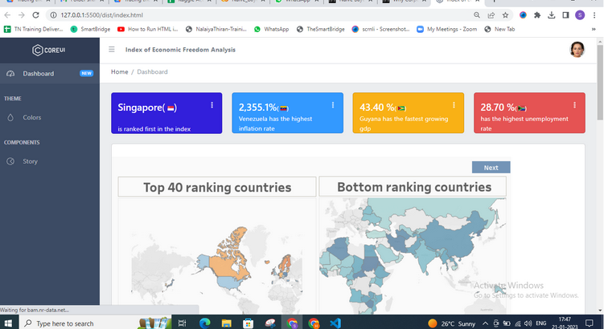

**Performance Testing**

Performance testing in Tableau helps ensure dashboards and reports load quickly and run efficiently, even with large data volumes or complex visualizations.

**Amount of Data Rendered to DB**

The amount of data that is rendered to a database depends on the size of the dataset and the capacity of the database to store and retrieve data.

Open the MySQL Workbench, go to the database then click to expand the tables,select the table and click on (i) button to get the information related to table such as column count,table rows etc.

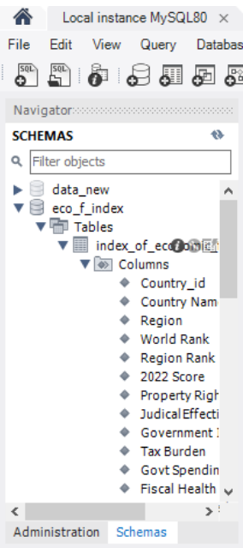

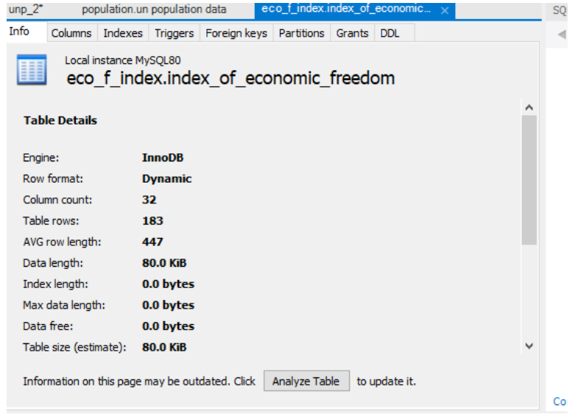

**Utilization of Data Filters**

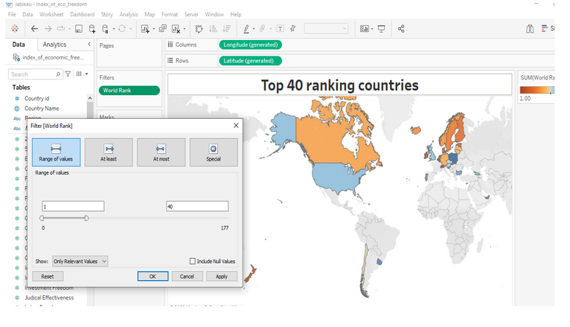

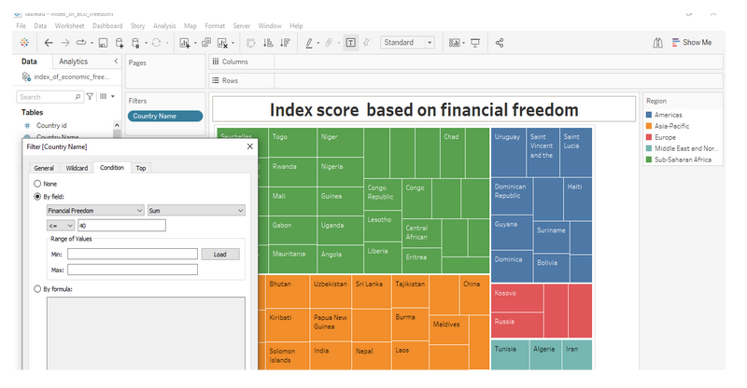

***Clean Data from Excel, CSV, PDF, and Google Sheets with Data Interpreter***

***Applies to: Tableau Cloud, Tableau Desktop, Tableau Server***

***When you track data in Excel spreadsheets, you create them with the human interface in mind. To make your spreadsheets easy to read, you might include things like titles, stacked headers, notes, maybe empty rows and columns to add white space, and you probably have multiple tabs of data too.***

***When you want to analyze this data in Tableau, these aesthetically pleasing attributes make it very difficult for Tableau to interpret your data. That’s where Data Interpreter can help.***

***Tip: Though Tableau's Excel add-in is no longer supported, Data Interpreter can help you reshape your data for analysis in Tableau.***

***What does Data Interpreter do?***

***Data Interpreter can give you a head start when cleaning your data. It can detect things like titles, notes, footers, empty cells, and so on and bypass them to identify the actual fields and values in your data set.***

***It can even detect additional tables and sub-tables so that you can work with a subset of your data independently of the other data.***

***After Data Interpreter has done its magic, you can check its work to make sure it captured the data that you wanted and identified it correctly. Then, you can make any necessary adjustments.***

***After you select the data that you want to work with, you might also need to do some additional cleaning steps like pivoting your data, splitting fields, or adding filters to get the data in the shape you want before starting your analysis.***

***Note: If your data needs more cleaning than what Data Interpreter can help you with, try***[***Tableau Prep(Link opens in a new window)***](https://www.tableau.com/products/prep)***.***

***Turn on Data Interpreter and review results***

1. ***From the Connect pane, connect to an Excel spreadsheet or other connector that supports Data Interpreter such as Text (.csv) files, PDF files or Google sheets.***
2. ***Drag a table to the canvas (if needed), then on the Data Source page, in the left pane, select the Use Data Interpreter check box to see if Data Interpreter can help clean up your data.***

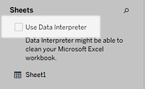

***Note: When you clean your data with Data Interpreter, Data Interpreter cleans all the data associated with a connection in the data source. Data Interpreter does not change the underlying data.***

1. ***In the Data pane, click the Review the results link to review the results of the Data Interpreter.***

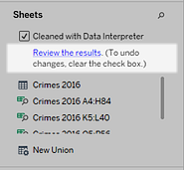

***A copy of your data source opens in Excel on the Key for the Data Interpreter tab. Review the key to find out how to read the results.***

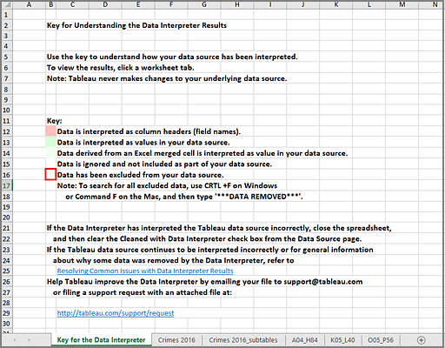

1. ***Click each tab to review how Data Interpreter interpreted the data source.***

***If Data Interpreter found additional tables, also called found tables or sub-tables, they are identified in the <sheet name>_subtables tab by outlining their cell ranges. A separate tab is also included for each sub-table, color coded to identify the header and data rows.***

***If Data Interpreter does not provide the expected results, clear the Cleaned with Data Interpreter check box to use the original data source.***

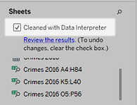

1. ***To replace the current table with any of the found tables, drag the current table off the canvas and then drag the found table that you want to use to the canvas.***

***If Data interpreter has misidentified the range of the found table, after you drag the found table to the canvas, click the drop-down arrow on that table, and then select Edit Found Table to adjust the corners of the found table (the top-left cell and bottom-right cell of the table).***

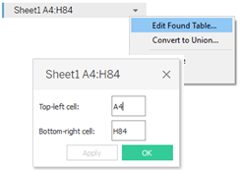

1. ***After you have the data that you want to work with, you can apply any additional cleaning operations to your data so that you can analyze it.***

***Data Interpreter Example***

***In this example we are connecting to an Excel spreadsheet with violent crime data by city and state for the year 2016. This spreadsheet includes multiple tables on one sheet and some extra formatting.***

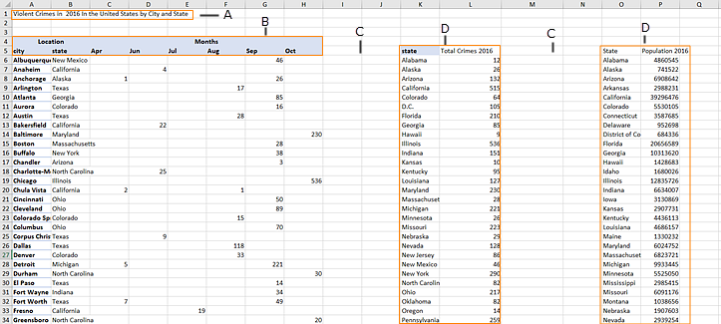

1. ***Title***
2. ***Merged header cells***
3. ***Extra white space***
4. ***Sub-tables***

***The extra formatting in this spreadsheet makes it difficult for Tableau to determine what the field headers and values are.***

***Instead, it reads the data vertically and assigns each column the default value F1, F2, F3 (Field 1, Field 2, Field 3) and so on. Blank cells are read as null values.***

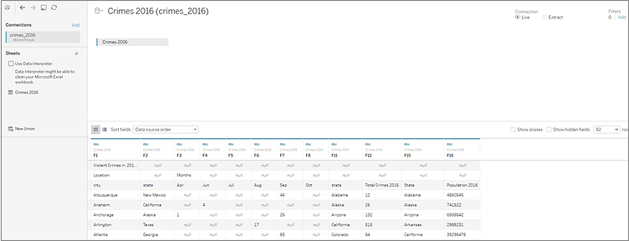

***To see if Data Interpreter can help clean this data set, we select Use Data Interpreter.***

***Data Interpreter detected the proper headings for the fields, removed the extra formatting and found several sub-tables. The sub-tables are listed in the Sheets section in the Data pane and are named using the original sheet name and the cell ranges for each sub-table.***

***In this example there are three sub-tables: Crimes 2016 A4:H84, Crimes 2016 K5:L40, and Crimes 2016 O5:P56.***

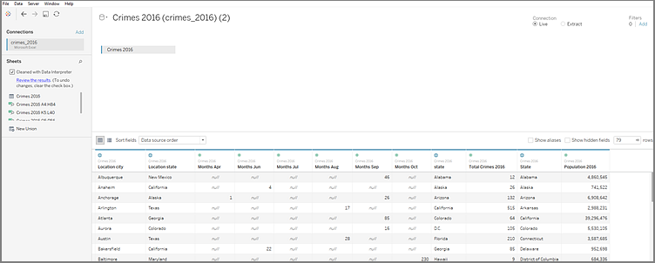

***To examine the results of the Data Interpreter more closely, we click the Review the results link in the Data pane to view an annotated copy of the spreadsheet.***

***Here we see a copy of the original data, color coded to identify which data was identified as header data and which data was identified as field values.***

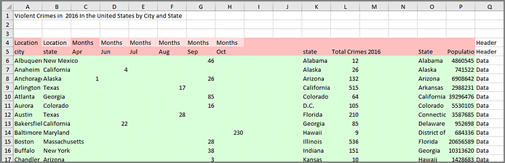

***The next tab shows us the sub-tables that Data Interpreter found, outlined by the cell ranges.***

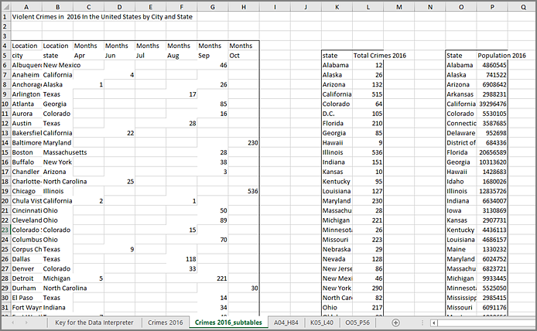

***In this example the first sub-table, Crimes 2016 A4:H84, has the main data that we want to work with. To use this table as our data table, we can simply drag the original table off the canvas and then drag the new table to the canvas.***

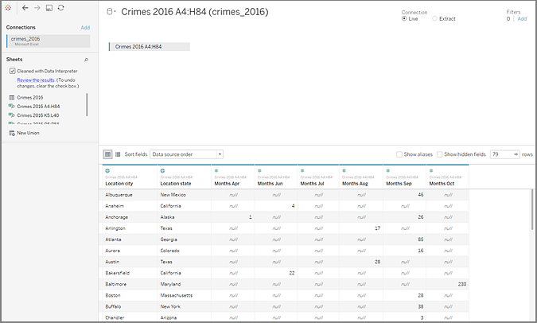

***Once we have the data that we want to work with in the canvas, we can do some additional clean up on the data. For example we can:***

* ***Change the field names so that they represent city, state, and month names.***
* ***Pivot the months fields.***
* ***Drag in the third sub-table Crimes 2016 o5:P56 and join it to our first sub-table on the State field to include state populations for our analysis.***
* ***Hide any duplicate fields that were added as a result of the join.***

***The results might look something like this:***

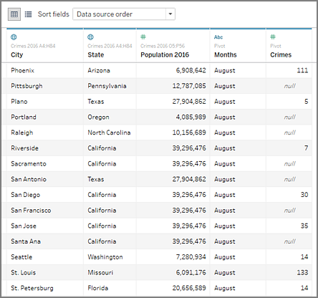

***Now we are ready to start analyzing our data in Tableau.***

***When Data Interpreter is not available***

***The Data Interpreter option might not be available for the following reasons:***

* ***The data source is already in a format that Tableau can interpret: If Tableau Desktop doesn't need extra help from Data Interpreter to handle unique formatting or extraneous information, the Data Interpreter option is not available.***
* ***Many rows or many columns: The Data Interpreter option is not be available when your data has the following attributes:***
  + ***Data contains more than 2000 columns.***
  + ***Data contains more than 3000 rows and more than 150 columns.***
* ***The data source is not supported: Data Interpreter is only available for Microsoft Excel, Text (.csv) files, PDF files and Google Sheets. For Excel, your data must be in the .xls or .xlsx format.***